HR SCORECARD SUCCESS IN TALENT MANAGEMENT.

* 1. **OVERVIEW.**

**INTRODUCTION.**

The tableau HR scorecard is a framework designed to measure and evaluate the success of talent management strategies within an organization.it provides a way for HR professionals and business leaders to track and analyse key performance indicators (KPIs) related to workforce planning , recruitment, retention, and development .

**THE HR SCORECARD CONSIST OF FOUR MAIN PERSPECTIVES:**

1. Financial Perspective**: This perspective focuses on the financial impact of HR initiatives , such as the cost of requirement , training and development , compensation and benefits , and turnovers .**
2. Customers Perspective: **This perspective measures the satisfaction of internal and external customers of HR services, including employees , managers , and job candidates. It includes KPIs such as employee engagement , manager satisfaction with HR support , and candidates experience**
3. **Internal process perspective: The perspective assesses the effectiveness and efficiency of HR processes, such as recruiting, on boarding, performance management, and employee development. It includes KPIs such as time to fill vacancies, time to productivity for new hires, and training hours per employee.**
4. **Learning and growth perspective: This perspective evaluate the organization’s investment in employee development and its ability to innovate and adapt to changing business needs. It includes KPIs such as employee skills and competencies, employee retention, and the percentage of employee who receive training and development.**
   1. PURPOSE.

THE USE OF THIS PROJECT. WHAT CAN BE ACHIEVED USING THIS .

**A HR scorecard in talent management can help measure and improve various aspects of workforce performance and development. Key achievement using an HR scorecard include:**

1. Performance measurement:

Evaluate individual and team performance against predefined goals, enabling a more objective assessment.

1. Identifying High performance:

Pinpoint top talent within the organization, aiding in recognition and targeted development initiatives.

1. Succession planning:

Succession planning by identifying and grooming employees for leadership roles, ensuring a smooth transition.

1. Skill Gap Analysis:

Identify skill gaps within the workforce and implement targeted training programs to enhance overall capabilities.

1. Employee Engagement:

Measure and enhance employee engagement by understanding factors affecting satisfaction and taking corrective actions.

1. Retention strategies:

Identify factors contributing to employee turnover and implement strategies to retain key talent.

1. Recruitment Effectiveness:

Evaluate the success of recruitment efforts by assessing the quality and performance of new hires.

1. Cost Efficiency:

Optimize human resources costs by aligning talent management efforts with organizational goals and priorities.

1. Strategic Alignment:

Ensure that talent management practices align with overall strategic objectives of the organization.

1. Data-Drive Decision making:

Making informed decisions based on data, promoting a culture of evidence based HR practices.

1. Continuous improvement:

Establish a framework for ongoing evaluation and improvement of talent management processes.

In summary, an HR scorecard in talent management provides a structured approach to measure, analyse, and enhance various aspects of workforce performance, ultimately contributing to organization success.

**2. Problem definition &Design thinking**

2.1 Empathy map

**Empathy map screen short;**

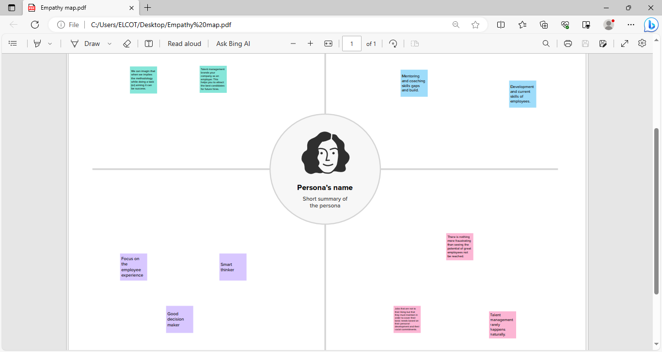

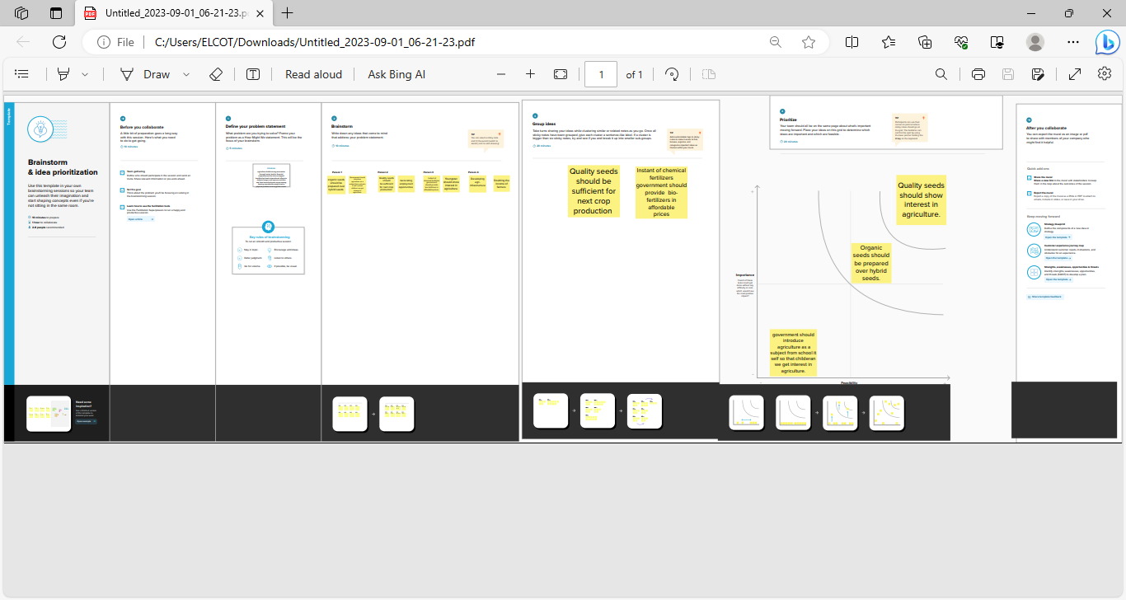**2.2**  Ideation & Brainstorming

**BRAIN STROMING SCREEN SHOT.**

**IDEATION.**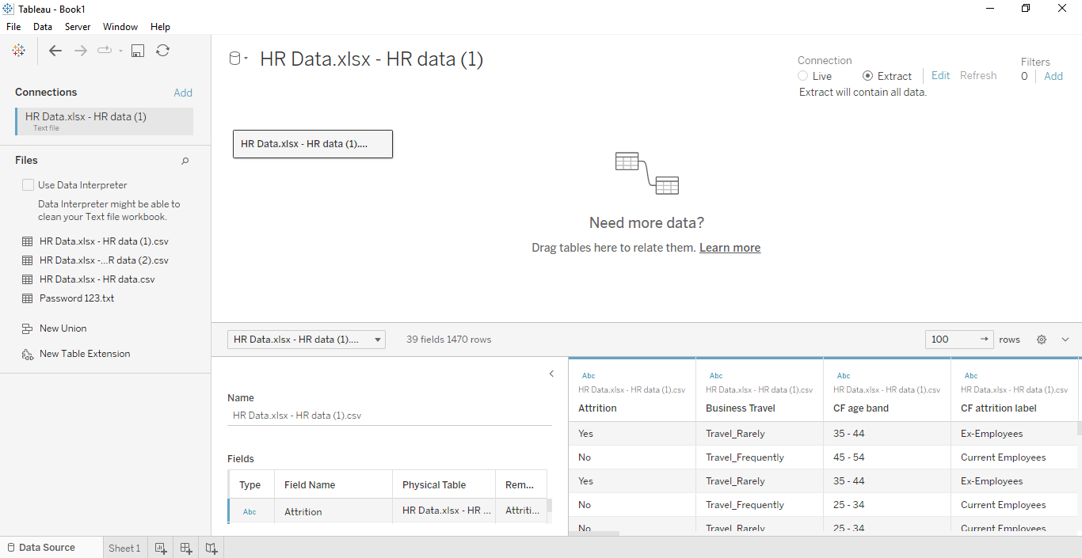

**3. RESULT**

**Final findings (output) of the project along with screenshots.**

**Visualization screenshots ;**

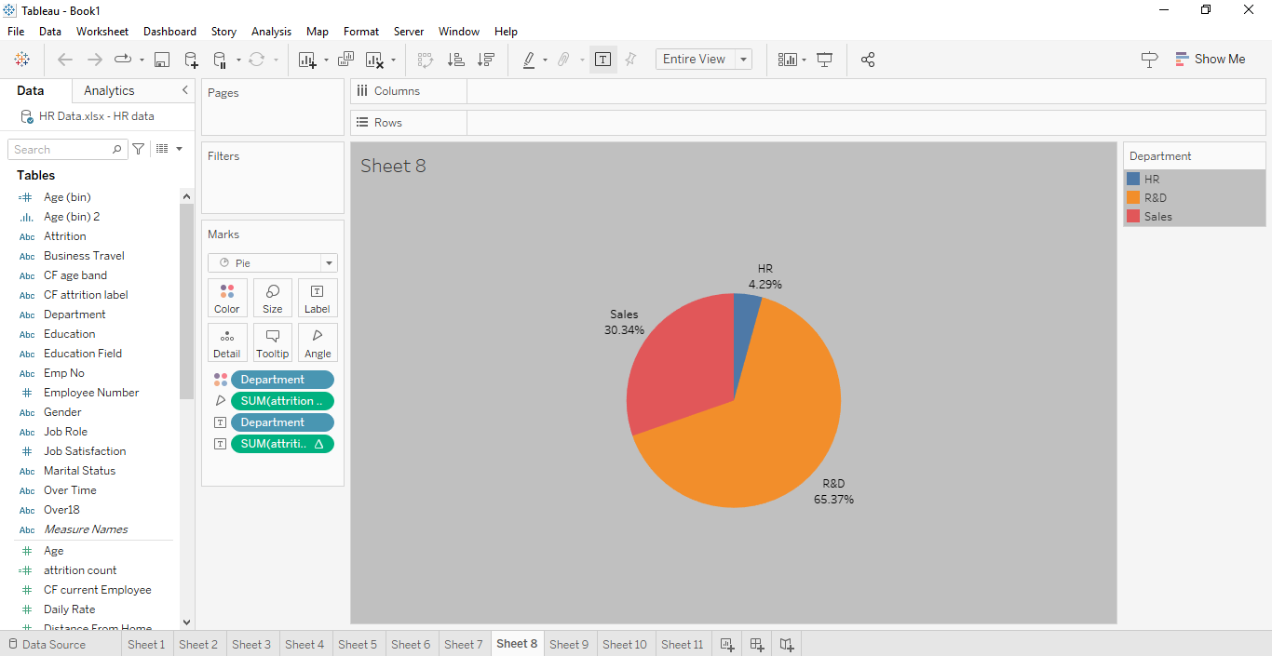**1.**

2

0**02.**

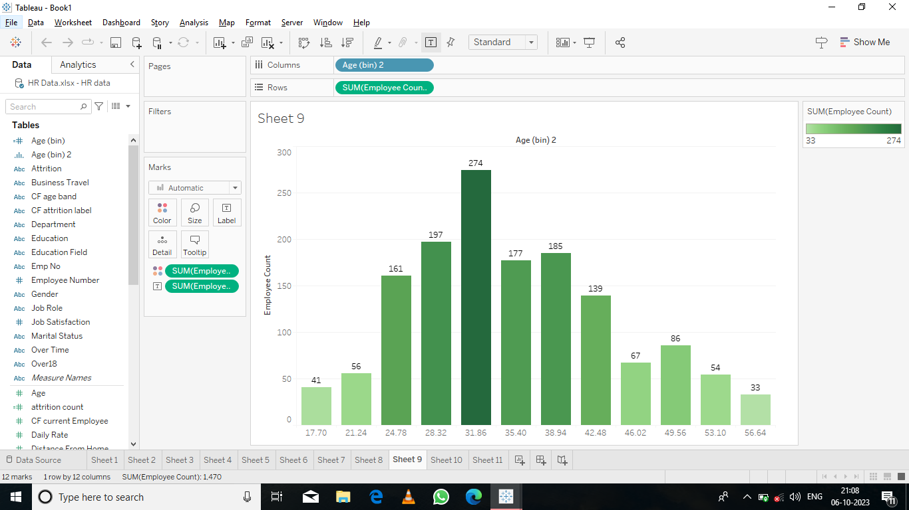

**3.**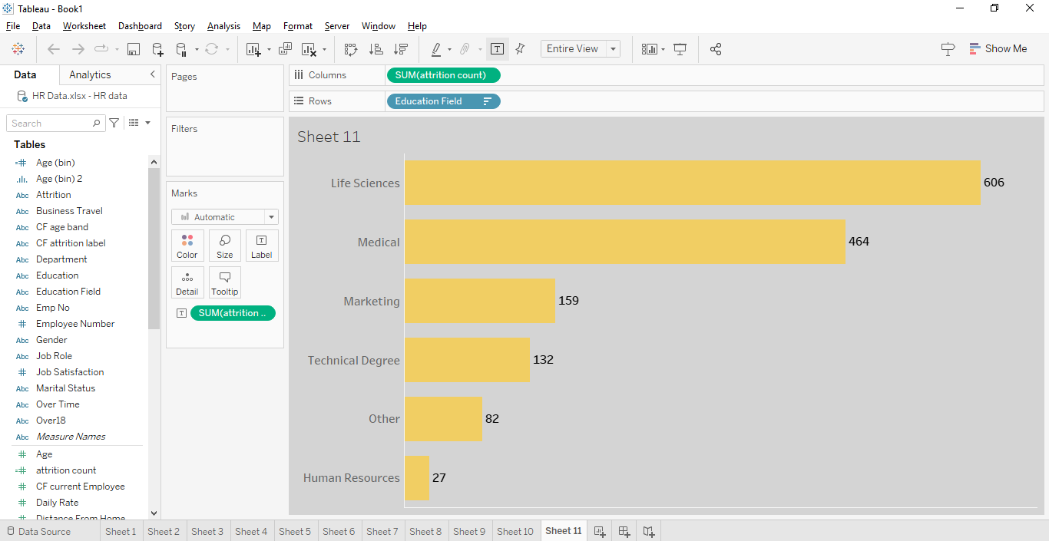

4.**4.**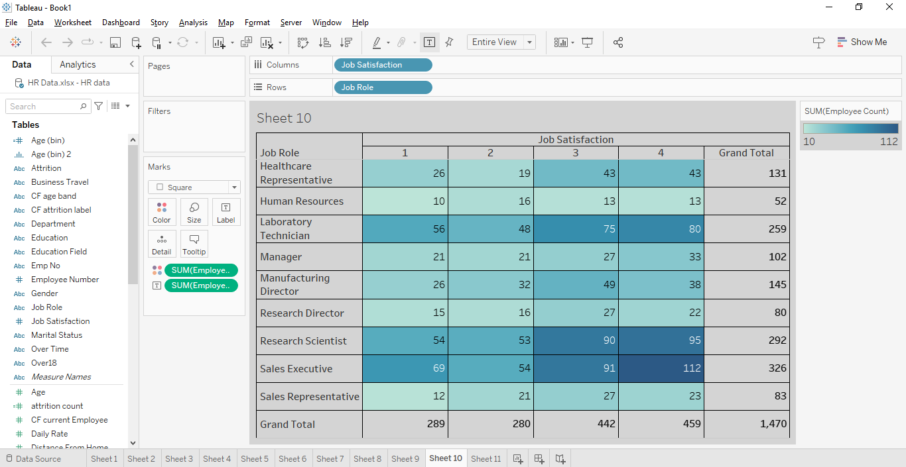3.3.3.da

**DASHBOARD SCREENSHOT.**

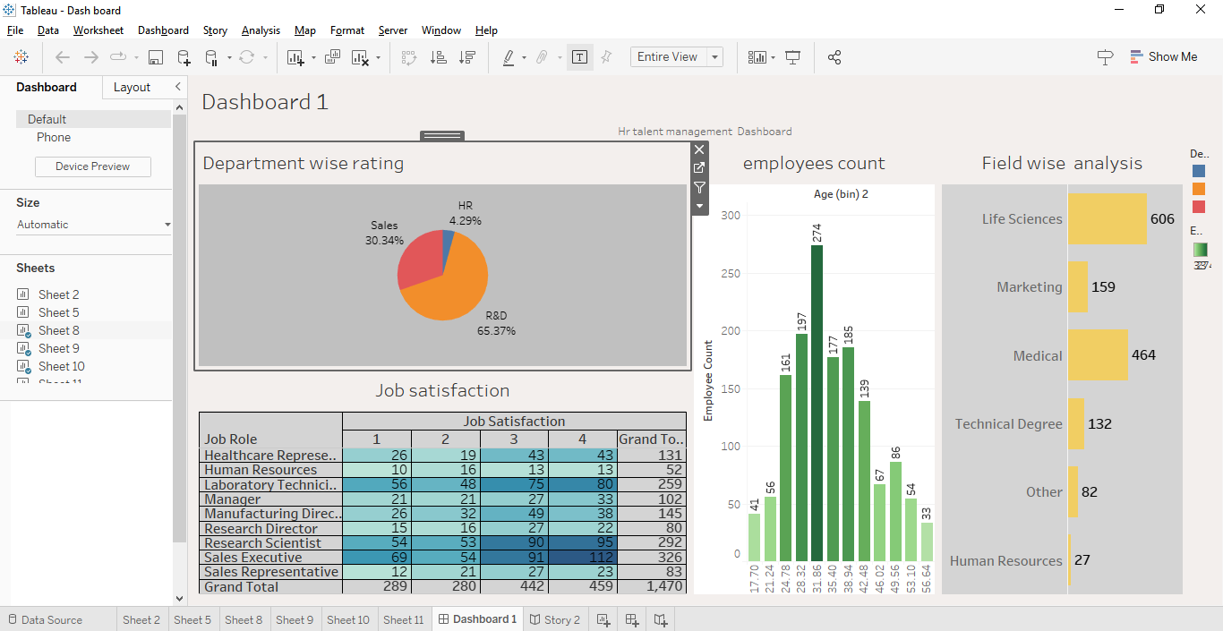

**STORY SCREEN SHOT.**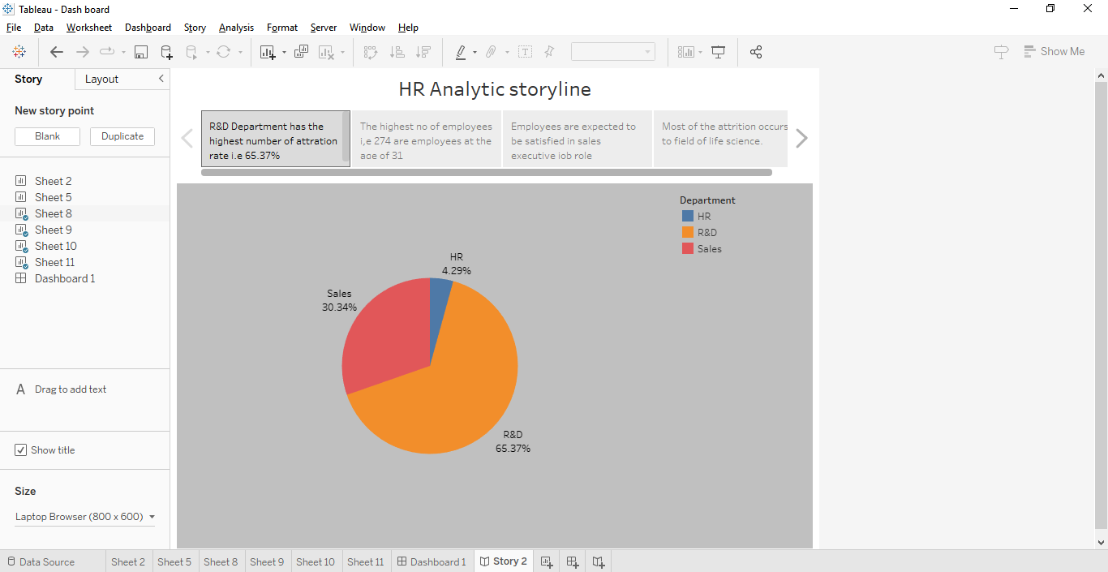

**FIG 0.1**

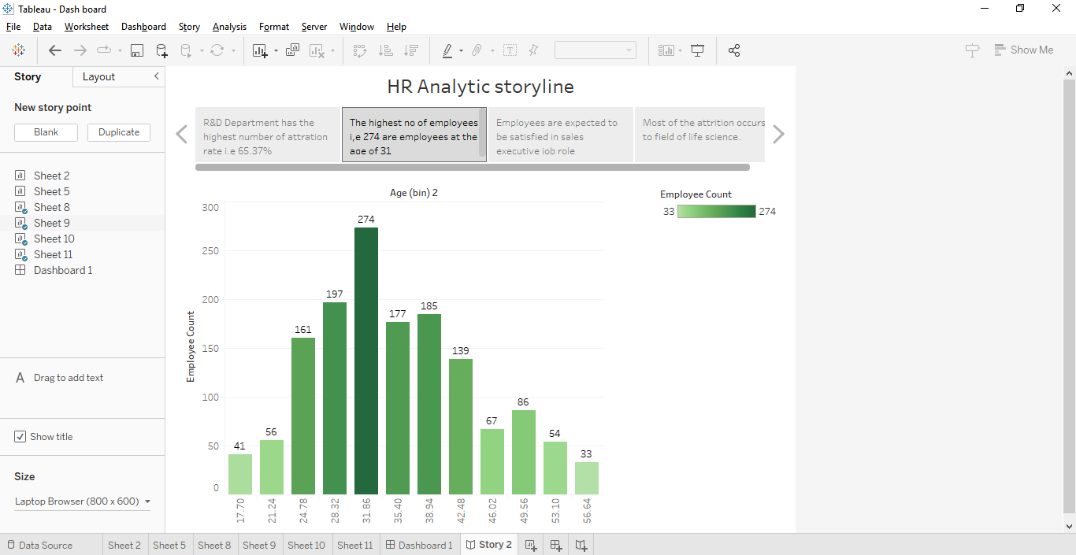

**FIG 0.2**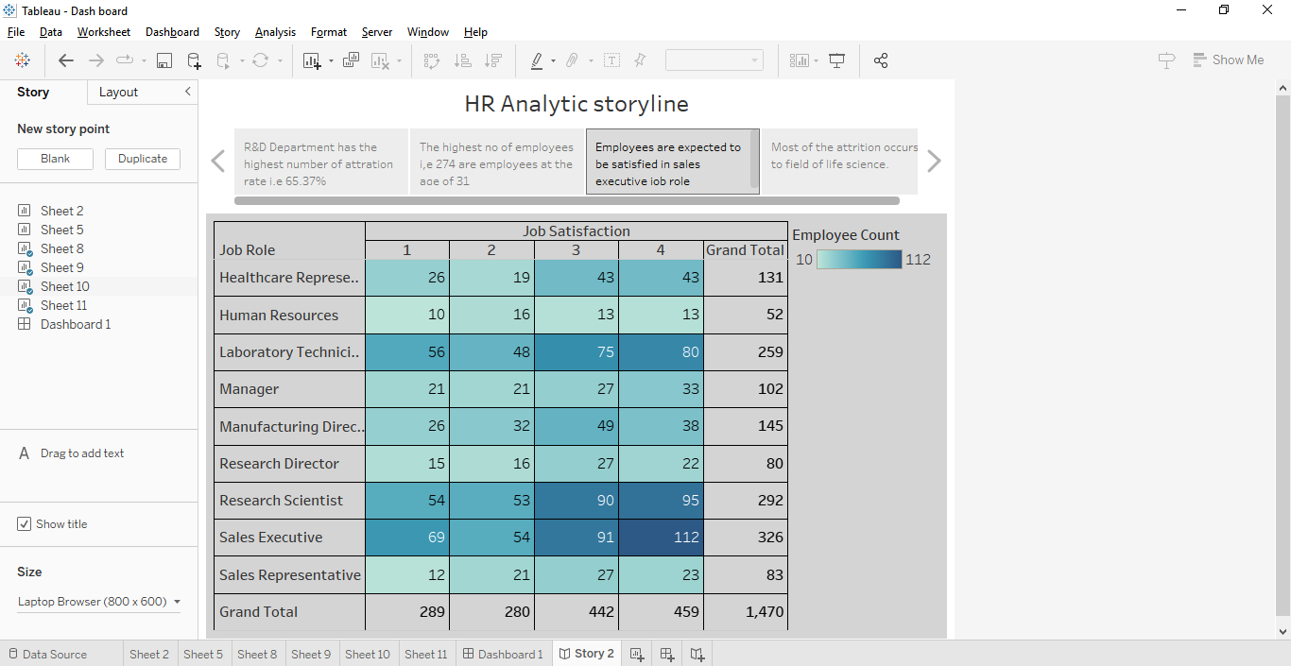

**FIG 0.3**

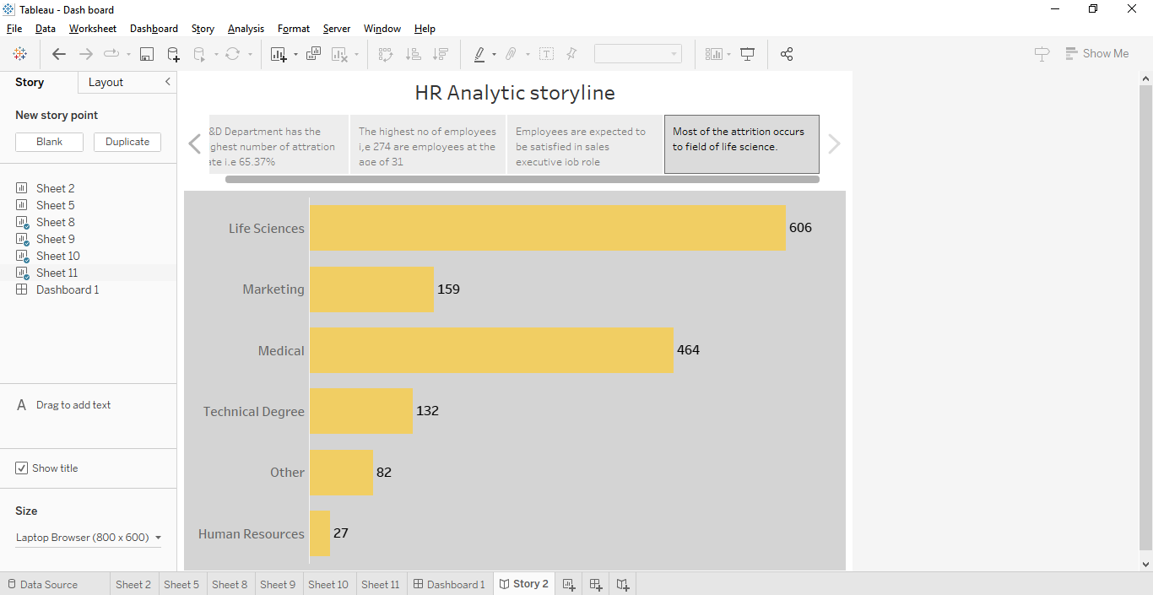

**FIG 0.4**

**4.**ADVANTAGES & DISADVANTAGES.

**Advantages of HR scorecard in talent management.**

**1.**Strategic **Alignment:** Ensure that talent management efforts align with organizational goals, promoting a more strategic approach.

2. Measurable objectives: Facilities the setting of clear, measurable objectives for HR and talent management initiatives.

3. Performance Evaluation: Enables objective performance evaluation , helping identify high performance amd areas for improvement.

4.Data-Drive Decision: Encourages data-drive decision-making,fostering a more evidence-based and informed HR strategy.

5.Talent Development: Supports targeted talent development initiatives by identifying skill gaps and training needs.

Disadvantages of HR scorecard in Talent management.

1.Overmphasis on metric: There’s a risk of focusing too much on metrics at the expense of qualitative factors, potentially missing important nuances.

2.Data Accuracy challenges: Relies on accurate and up-to-up date data: inaccurate data can lead to flawed conclusions and decision.

3. Complexity: Implementing and maintaining an HR scorecard system can be complex, requring significant time and resources.

4.Resistance to Measurement: Some employees may resist being measured or feel that metrics oversimpliyf their contributions.

5.Subjective in Metrics : Certain metrics may have a degree of subjectivity, especially in areas like employee engagement or leadership potential.

**5.APPLICATION;**

The HR scorecard in talent management solutions can be applied across various organizational functions to aptimize human resources and enhance overall perfarmance.Here are some specific areas where the HR scorecard can be successfully implemented:

**1.Recruitment and onboarding:**

* Measure the effectiveness of recruitment processes.

* Evaluate the quality and performance of new hires.

**2. Perfomance Management:**

* Set and measure performance goals for individuals and teams.

* Assess employee performance against established metrics

**3. Employee Development:**

* Identify skill gaps within the workforce.

* Implement targeted training and development programs.

**4.Succession planning:**

* Identify and prepare employees for leadership roles.

* Evaluate the readliness of potential successors.

**5.Employee Engagement:**

* Measure employee satisfaction and engagement levels.

* Identify factors infiuencing engagement and morale .

**6.Cost optimization:**

* 0ptimize human resources costs by focusing on high-impact intiatives.

*Assess the return on investment (ROI) of various HR programs.

**7.Diversity and inclusion:**

* Measure diversity and inclusion metrics within the workforce.

* Implement initiatives to promote diversity and inclusion.

**8.Continuous Improvement:**

* Establish a framework for ongoing evaluation and impovement.

* Regularly review and update HR scorecard metrics based on organization needs.

* Foster a culture of continuous improvement in talent management practices.

Implementing the HR scorecard in these areas requires collaboration between HR professionals , leadership, and other stakeholders. It serves as a valuable tool for monitoring ,analysing, and enhancing various aspects of talent management to contribute to organization success.

**7. CONCLUSION**

In conclusion, the HR scorecard proves to be a robust tool in achieving success in talent management across diverse organizational function.Its application provides a strategic framework for aligning human resources initiatives with overall organizational goals .The key findings and outcomes from implementing an HR scorecard include:

1. **Strategic alignment:**

The HR scorecard ensure that talent management practices are directly linked to the strategic objectives of the organization, fostering a more cohesive and purposeful workforces. **2.Measurable objectives:**

Clear and measurable objectives are set,allowing for precise evaluation of individuals and team performance , contrbuting to a more data-driven decision-making process.

**3.Talent Development:**

Skill gaps are identified ,and targeted training programs are implemented, enhancing the capabilities of the workforce and promoting continuous and learning.

**4.Succession planning:**

Through systematic evaluation , the HR scorecard aids in identifying and preparing potential leaders, ensuring a smooth transtion and minimizing disruption in key roles.

**5.Employee Engagement:**

Metrics related to employee satisfaction and engagament provides valuable insight, enabling the implementation of initiatives to improve overall morale and commitment.

**6.Cost Optimization:**

Human resources costs are optimized by focusing on high – impact initiatives and the return on investment ( ROI ) of various HR programmes is assesed .

**7.Continuous improvement:**

The HR score card establishes a frame work for continuous evoluation and improvement, promoting a culture of on going enhancement in talent management practice.

Its successful implemantation empowers organization to make informed decission, nurture talent, and continually evolved in a dynamic business landscape.

**7.FUTURE SCOPE**

The future scope for HR scorecard success in talent management is promising, with several trends and potential development that can shape its evolution. Here are some aspects to consider.

**1.Integration of advanced techonologies:**

* **AI and mechine learning:** Utilize advanced analytices and predictive modelling to identify trends, forecast talent needs, and enhance decision-making.
* **HR Software integration:** Seamless integration with HR software to automate data collection, analysis, and reporting.

**2.Emphasis on employee experience:**

* Incorporate metrics related to employee experience, weii-being, and work-life balance, reflecting the growing importance of holistic employee engagement.

**3.Divesity, Equity, and inclusion (DEI) Metrics:**

* Integrate metrics focusing on diversity,equality,and inclusion to ensure organization are fostering diverse and inclusive workplaces

**4.Global Talent metrics :**

* Develop metrics that account for the unique challenges and opportunities in managing a global and diverse workforce.

**5.Ethical AI in Decision-making:**

* Ensure ethical considerstions in the use of AI for decision-making , especially in sensitive areas like performance evaluation and talent selection.